Machine Learning - ML1819

Research Assignment 2

**TEAM ID:** 08  **Module:** CS7CS4 **Task ID:** 104

**Lecturer:** Hannah Archbold, Joeran Beel, Sarah-Jade Evenden, Ronan Kane, Douglas Leith, Gillian Long , Margaret Murray

**Assignment Title:** How much data do you need to train machine learning algorithms effectively?

**Group Members:** Saad Tariq Malik (18313001), Shuqi Wu (18301412), Yifei Fang (18301179)

**Contributions:**

|  |  |  |  |  |
| --- | --- | --- | --- | --- |
|  | Preprocessing | Model Modification | Literature Review | Documentation |
| Saad Tariq Malik | **√** | **√** |  | **√** |
| Yifei Fang | **√** | **√** |  | **√** |
| Shuqi Wu | **√** |  | **√** | **√** |

Preprocessing task: Feature Selection, Feature Encoding, and Feature Scaling

Model Modification: Modifying the current scripts of Logistic Regression Model, developing a new script for Linear Regression Model, and adding new evaluation metrics to analyze models.

**Assignment Length:**  5 Pages Including 1343 Words

**Exceptional Circumstances:** N/A

Git Repo: <https://github.com/Shuqi-Wu/ML1819--task-104--team-08>

Git Repo Activity URL: <https://github.com/Shuqi-Wu/ML1819--task-104--team-08/graphs/contributors>

Git Activity Screenshot:

 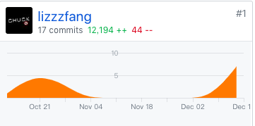

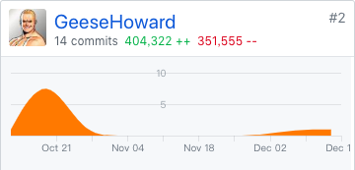 

Impact of Training Data on the Performance of Linear Regression and Logistic Regression

|  |  |  |  |
| --- | --- | --- | --- |
| Saad Tariq Trinity College Dublin Ireland maliksa@tcd.ie | | Yifei Trinity College Dublin Ireland fangy@tcd.ie | Shuqi Wu Trinity College Dublin Ireland wush@tcd.ie |
|  |

# Introduction

Adequate amount of data is crucial to the process of training of a machine learning algorithm and its performance. Training data allows us to tune our model’s parameters as best as possible, whereas testing data allow us to measure and judge how well our trained model performs with new input data. Determining sufficient amount of training data is therefore integral for the synthesis of an efficient machine learning model.

This paper measures the impact of increasing the training data on the performance of machine learning algorithms. Our goal is to investigate various metrics associated with the performance of a machine learning algorithm and determine whether the empirical results are harmonious with the theoretical framework behind the algorithms.

# RELATED WORK

Brian et al. investigated the effect of increasing data size on bias-variance tradeoff for classification algorithms [1]. The paper found that increasing data set sizes leads to increase in variance (which leads to overfitting) and has negligible impact on bias. Galdi et al. They reviewed and contrasted the different metrics used to evaluate machine learning algorithms and noted a positive correlation between training data and predictive accuracy of the model [4]. For performance evaluation, Marina et al. [5] compared several different evaluation measures, such as accuracy, precision, recall, F-score, and the Receiver Operating Characteristic (ROC).

# methodology

For this paper, we decided on evaluating the two fundamental Machine Learning algorithms, namely Linear Regression and Logistic Regression. We investigated the impact of progressively increasing amount of training data on the performance of the two chosen algorithms.

The metrics we used to evaluate the performance of Logistic Regression are Accuracy, Log Loss, Area under ROC, and Confidence Intervals. For Linear Regression, Mean Absolute Error (MAE), R-squared coefficient, and Confidence Intervals are prime evaluation for quantifying the quality of prediction. [3]

**3.1 Collecting datasets**

There are three datasets used in the assignment: one for Linear Regression and two for Logistic Regression (Table 1). The datasets are publicly available at the UCI Machine Learning Repository.

**Table 1: General Description of Datasets**

|  |  |  |  |
| --- | --- | --- | --- |
| Dataset | Associated Tasks | Number of Features | Number of instances |
| Beijing PM2.5  Data | Linear Regression | 11 | 40k |
| Census Income  Data | Logistic Regression (Simple*) | 14 | 33k |
| Dota2 Game  Results | Logistic Regression (Complex*) | 116 | 92k |

*‘Complex’ dataset has over 3X the features of a ‘Simple’ one

**3.2 Preprocessing**

**3.2.1 Feature Selection.** We managed to use the real valued features in datasets out of the box. Most categorical, nominal features with multiple values like ‘Birthplace’ were removed from the datasets. Instances with missing values of features (which comprised less than 5% of the datasets) were removed. We plotted both feature **correlation matrix** and **feature importance graph** to determine features that exhibited high correlation with each other. Coefficients that are larger than 0.5 represent a moderate linear relationship, and those larger than 0.7 indicate a strong linear relationship. E.g., **Figure-2** shows features with very little correlation, therefore there was no need to strip any of those features.

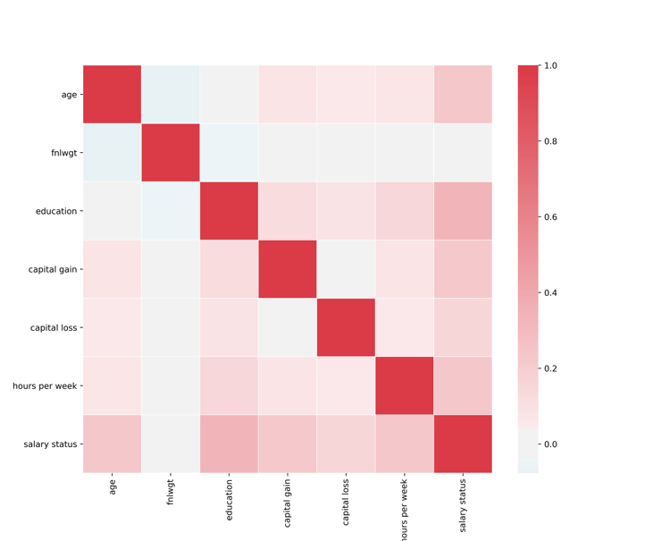

**Figure 1: Correlation of Census Income Data**

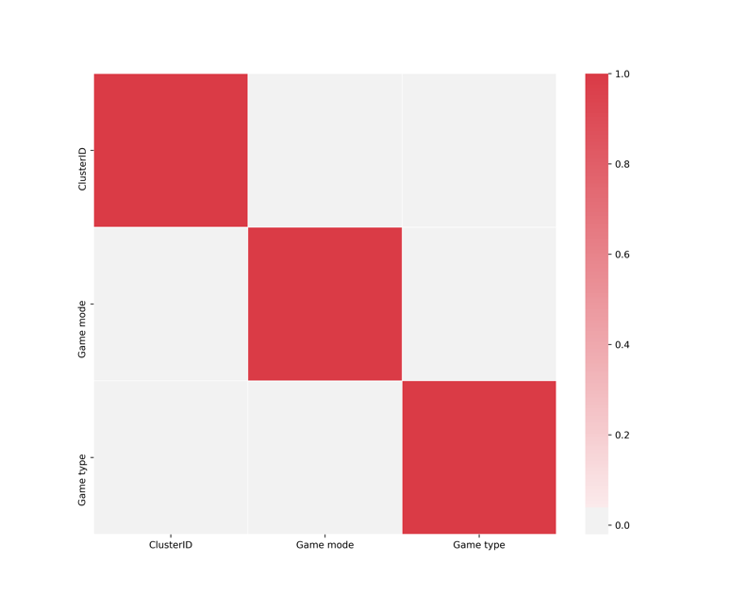

**Figure 2: Correlation of Dota2 dataset features**



**Figure 3: Correlation of Beijing PM2.5 Data**



**Figure 4: Variable Importance of Beijing PM2.5 Data**

Our chosen algorithms are known have poor performance with highly correlated features. Therefore, we calculated the correlation between features, and stripped the datasets of features that had a high correlation with each other, and features with low correlation with the data. We use Pearson’s correlation coefficient in computing the features correlation matrix. Fig. 1, Fig. 2 and Fig. 3 shows the correlation plots of our datasets [2].

Random forest ensemble model was used to calculate the variable importance and removed the last two unimportant features of ‘cv’ and ‘ls’ in Beijing PM2.5 Data according to Fig 4.

**3.2.2 Feature Encoding.** Certain ordinal categorical features like gender were deemed to have a strong impact on the performance of the algorithm. Therefore, we employed **One-Hot Encoding** to features such as ‘Work class’ in the Census Income dataset. We also applied an alternative method **Dummy Encoding**, e.g. the ‘cbwd’ column in Beijing PM2.5 Data has four values. We replaced it with four columns: cv, NE, NW, and NE using binary representation.

**3.2.3 Feature Scaling**. Feature scaling was also performed on the datasets. For instance, the feature ‘*fnlwgt’* from the Census Income Dataset ranged between 12285-1484705, while the capital-gain parameter ranged from 0-1000 etc. We applied **Min-Max Normalization** on such features.

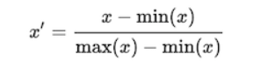

**3.3 Algorithms**

Due to the large size of the datasets, Hold-Out method was mainly used instead of K-Fold validation.

We developed scripts that measured performance as follows:

For Logistic Regression Model:

Repeat {

* Randomly select **n** training samples from dataset having **N** instances.
* Train the model using the **n** samples.
* Test the model against the remaining (**N**-**n**) samples by performing cross validation.
* Calculate metrics.
* Increase **n**.

}

For Linear Regression Model:

Repeat {

* Select **n** training samples from the shuffled dataset.
* Train the model using the **n** samples
* Test the model with the total dataset.
* Calculate metrics
* Increase **n**.

}

# results and discussion

This section provides a summary of the results, along with a detailed analysis of our findings

**4.1 Summary**

For Logistic Regression, the results showed that the impact of training data was more pronounced on the complex dataset than it was on the simple one, for which performance stabilized quickly and no trends could be identified.

For the Linear Regression algorithm, half of the data from the In Beijing PM2.5 dataset is enough to achieve a reasonable performance. To avoid overfitting problem, we should not take the huge amount of data in training the model.

In summary, the size of training data had a strong and positive impact on both Linear Regression and Logistic Regression. Nevertheless, only small proportion of data is necessary for training these two models because the performance of models converges and remains stable after a certain point.

**4.2 Logistic Regression**

For the simple dataset, most of the performance metrics stabilized between 0-1000 interval. Within this interval, the accuracy rose from a low of 72% to 80% (Fig. 5). The log loss fell very sharply from 1.4 to 0.5 (Fig. 6). Finally, ROC fluctuated between 0.57 and 0.61 (Fig. 7) and did not seem to stabilize as training data was increased. For the complex dataset, a linear trend was observed across all metrics between 0-20000 instances of training data, and the accuracy rose from 52% to 59%, and the log loss fell from .85 to .67. The ROC increased from 0.52 to 0.63 (Fig. 8). The performance did not improve further after 20000 instances. Confidence intervals varied as per expectation for both the datasets (Fig. 9).

The only major discrepancy between the results of the two datasets is the fluctuation in ROC. The simpler dataset and the complex dataset both showed improved ROC, but the simpler dataset had ‘spikes’ while the complex dataset’s ROC curve was smoother. We hypothesize that training data has stronger impact on performance of Logistic Regression when the dataset has a lot of features, whereas for datasets with few features, training data has minimal impact on performance.

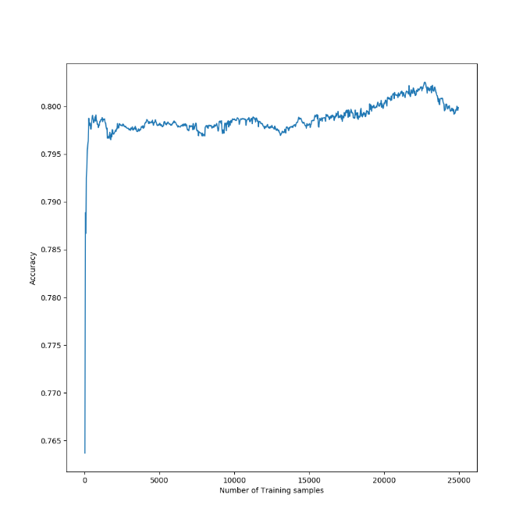

**Figure 5: Training data - Accuracy Graph (Simple Dataset)**

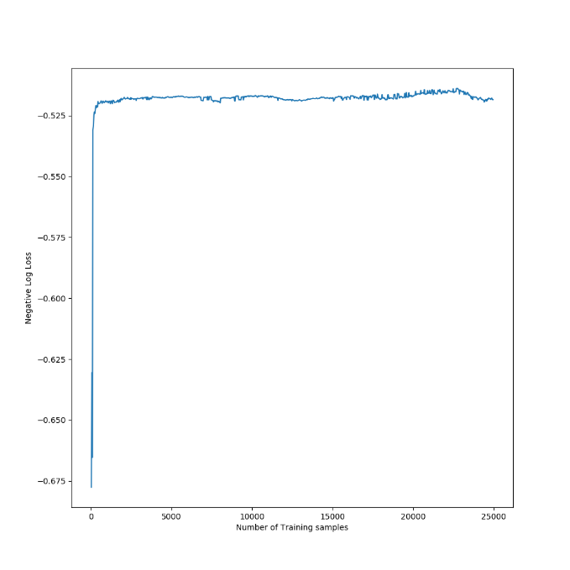

**Figure 6: Training data - Log Loss (Simple Dataset)**

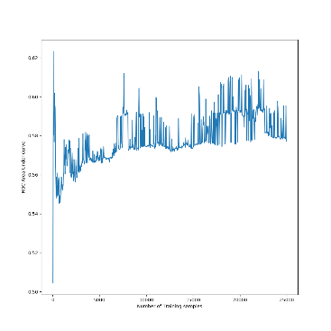

**Figure 7 Training Data – Area Under ROC (Simple Dataset)**

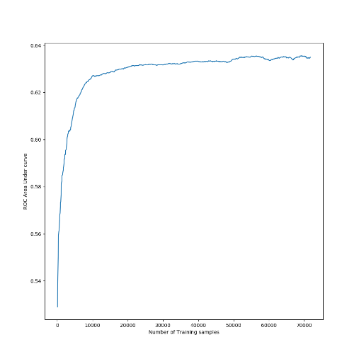

**Figure 8: Training Data – Area Under ROC (Complex Dataset)**

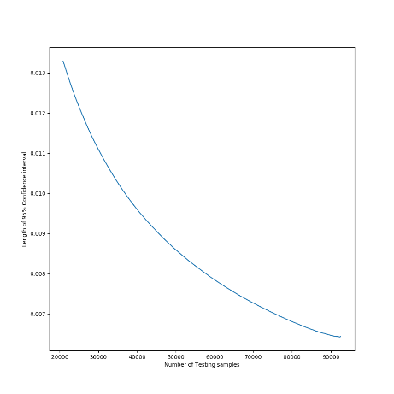

**Figure 9: Testing Data – 95% confidence interval length (Simple Dataset)**

**4.3 Linear Regression**

The performance of average R score could be improved from -0.1868 to 0.0363 mainly by utilizing feature selection and modifying the model. Apart from the general evaluation metrics, we added additional metric confidence intervals to measure the changes of our models’ predictions.



**Figure 10: MAE of increasing data amount**

There is a high volatility of MAE during the training data amount of 20 to 3500, then it recovers and stabilizes from approximately 0.45 onwards. (Fig. 10)



**Figure 11: R-squared coefficient of increasing data amount**

R-squared increases rapidly and does not change significantly until x-coordinate reaches approximately 5100. (Fig. 11)



**Figure 12: Confidence Intervals**

The graph is plotted under 95% confidence level. The Confidence Intervals starts at [0,0] and fluctuates in the previous iterations. However, it converges at iteration 1000 when the data amount is 20000. (Fig. 12)

In the particular problem – predicting Beijing PM2.5 with a linear regression model, we can conclude that training data size of 5100 is needed for training. However, 20000 out of 41758 is the ideal data amount after combining the results of the confidence intervals.

# LIMITATIONS

Our limitations within this research stem from the natural flaws of the data and the weakness of the chosen methodology. The noise in the data causes overfitting problem. Discarding the missing data from the original dataset could cause the nonresponse bias. Moreover, our chosen linear regression and logistic regression models are sensitive to outliers. The performance could be improved by changing the predicting models.

Further research is required to verify our hypothesis that training data strongly impacts datasets with high number of features.

# REFERENCES:

[1] Brian, D. (n.d.). On the effect of data set size on bias and variance in classification learning. Proceedings of the Fourth Australian Knowledge Acquisition Workshop.

[2] Brownlee, J. (2018). Visualize Machine Learning Data in Python With Pandas. [online] machinelearningmastery. https://machinelearningmastery.com/visualize-machine-learning-data-python-pandas/ [Accessed 28 Oct. 2018].

[3] Brownlee, J. (2018). Metrics To Evaluate Machine Learning Algorithms in Python. [online] machinelearningmastery. https://machinelearningmastery.com/metrics-evaluate-machine-learning-algorithms-python/ [Accessed 28 Oct. 2018].

[4] Galdi, P. (2018). Data Mining: Accuracy and Error Measures for Classification and Prediction. Reference Module in Life Sciences.

[5] Sokolova M., Japkowicz N., Szpakowicz S. (2006) Beyond Accuracy, F-Score and ROC: A Family of Discriminant Measures for Performance Evaluation. In: Sattar A., Kang B. (eds) AI 2006: Advances in Artificial Intelligence. AI 2006. Lecture Notes in Computer Science, vol 4304. Springer, Berlin, Heidelberg